**Health-Care Domain**

* **Health-care Domain Testing** is a process to test **Health-care** application for various factors like standards, safety, compliance, cross dependency with other entities, etc.
* The purpose of health-care domain testing is to ensure quality, reliability, performance, safety and efficiency of the Health-care application.
* **Why Do We Require An Application In Health-Care Domain..??**

(Note: This Point can be used to answer questions like, what was the need of this application? /What was the business requirement of the application? /What was the business flow of the application you worked on?)

* Whenever a new patient comes to the hospital, we need to do a **new registration** for the patient.
* If existing or new patient needs to schedule an **appointment** with any doctor
* To maintain the **visits** of all patients inside the hospital
* To **maintain the data** of doctors, nurses, other staff etc.
* To **maintain the stock** inside the hospital, the stock can be medicines, surgical instruments, house keeping stock, bed availability etc.
* To submit and validate **claims** for patients.

**Terminologies related to Heath-Care Domain :-**

****1.Insurer:****  
An entity or Insurance Company which creates plan, sell policy and reimburses policy holder or provider for the submitted valid claims.

****2.Policy-Holder:****  
Health-care policyholder (**Insured**) A person or an entity, who buys the policy from the insurer, pays premium to the insurer and sometimes submit claim.

****3. TPA(Third Party Administrator):****  
A person or an entity that manages the claims of policy holder or provider and receives payment for the management from the respective contributor.

(TPA -> Insurance Samadhan => <https://www.insurancesamadhan.com/> )

****4.BROKER:****  
Health-care insurance broker (**Insurance Agent**)  
He is an agent who sells policy to the customers on behalf of insurer and receives commission in return from the Insurer.

****5. Claims –**** “An invoice from the provider to the doctor for the services rendered”.

****6. Co-Insurance –**** A form of medical cost sharing in a health insurance plan that requires an insured person to pay a stated percentage of medical expenses after the deductible amount, if any, was paid.

****7. Co-payment –**** A form of medical cost sharing in a health insurance plan that requires an insured person to pay a fixed dollar amount when a medical service is received. The insurer is responsible for the rest of the reimbursement.

****8. Deductible**** – A fixed dollar amount during the benefit period – usually a year – that an insured person pays before the insurer starts to make payments for covered medical services.

****9. Medicare:**** A federal health insurance program for senior citizen and permanently disabled people.

****10. Medicaid:**** A joint and state program that helps low-income families and individuals pay for the cost associated with medical care.

****11. HIPAA**:** It is a set of rules and regulations which doctors, hospitals, health-care providers and health plan must follow in order to provide their services.

**Name of the Application: PMS (Practice Management Software)**

**Healtrhcare Domain Companies -**

GreenMed / AdvanceMed / PracticeMD / GreenWay / ProviderWay / NextGen / OpenEMR / Medfusion

* **In Which All Departments The Application Can Be Used..??**

The application can be used in all the departments available inside the hospital to provide a smooth service to any patients who is visiting.

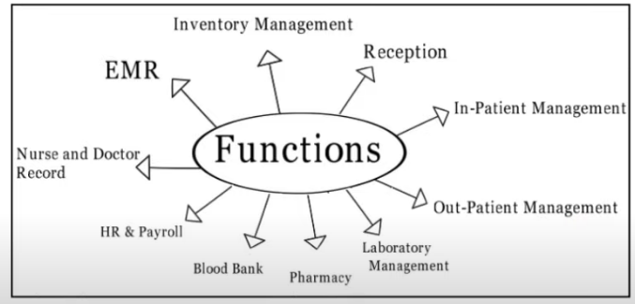

**Business Flow :-**

1. Practice Management Software is having many functionality to manage Hospital/Practice. One of them is **Billing Module**.
2. Most of the Hospital in United State are using **Practice Management Software** for smooth operation in their facility.
3. Using this PMS any Hospital can manage their **Appointment, Scheduling, Maintaining Patient Health Information (PHI), Billing Department, Credit Balance, and Inventory Management.**
4. They can manage their multiple branches using single platform.
5. Using Practice Management Software Hospital can get their reimbursement from Patient Insurance in Short period.

